MINIKUBE
Chuẩn bị:
VM: CentOS 7
- 2 CPUs or more
- 2GB of free memory
- 20GB of free disk space
- Cài đặt
Truy cập link: https://minikube.sigs.k8s.io/docs/start/

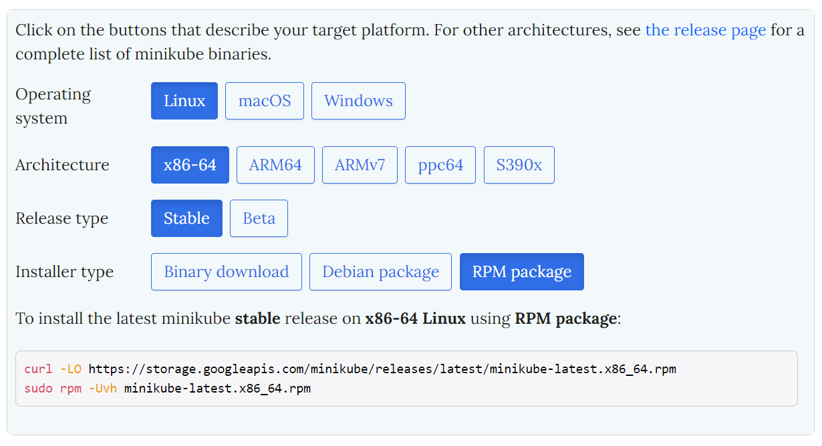

# curl -LO https://storage.googleapis.com/minikube/releases/latest/minikube-latest.x86_64.rpm
# sudo rpm -Uvh minikube-latest.x86_64.rpm

- Start Cluster
# minikube start
# minikube kubectl -- get pod -A
Thiết lập Alias:
# alias kubectl="minikube kubectl --"
Thêm Alias vào trong file .bashrc
# vi .bashrc
alias kubectl="minikube kubectl --"

# kubectl -- get pod -A
- Thiết lập Dashboard
# minikube dashboard
# kubectl proxy --address='0.0.0.0' --disable-filter=true
Mở trình duyệt, copy URL của dashboard:
http://server_ip:8001/api/v1/namespaces/kube-system/services/http:kubernetes-dashboard:/proxy/
- Deploy applications
# kubectl create deployment hello-minikube --image=kicbase/echo-server:1.0
# kubectl expose deployment hello-minikube --type=NodePort --port=8080
# kubectl get services hello-minikube
# minikube service hello-minikube
# kubectl port-forward service/hello-minikube –address server_ip 7080:8080
Truy cập trình duyệt: http// server_ip:7080
- Basic control
Stop cluster:
# minikube stop
Delete cluster
# minikube delete
Delete cluster and profiles
# minikube delete - -all
Show addon list
# minikube addons list

